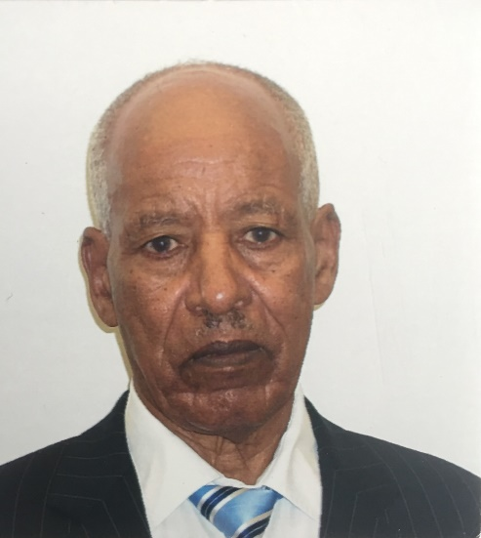
In Memoriam: The Late Memher Tekeste Habte
By Dr. Gebre Hiwet Tesfagiorgis

It was with a heavy heart that I learned of the passing away of my elementary-school teacher, Memher Tekeste Habte. He died on Friday, March 10, 2017 in New Jersey (USA) at the age of 85.
In the course of one’s personal and educational development, everyone can single out an individual who made the most significant impact on his/her life. For me, it was the late memher Tekeste Habte. He was my teacher during the formative years of my elementary education (first through fourth grade). Memher Tekeste was a stern disciplinarian, yet kind and caring. He was well versed especially in the lexicon and grammar of the Tigrinya language, which was evident not only in his normal conversation and general demeanor, but also in the way he departed that knowledge to his students. He was dedicated to his teaching profession and committed to his students. A former classmate of the time, who now lives in Seattle, Washington, upon my sharing with him the sad news, reminded me that we were in the morning shift of classes and that Memher Tekeste some days “forced” us to stay on the school grounds so that we could study and also take Arabic lessons in the afternoon. He knew that parental desire for helping hands on the farm will leave little time for studying. Such was his dedication and commitment and his desire for his students to excel.
Memher’s contributions can perhaps be best understood and appreciated in the context of the broader turbulent socio-political situation of the 1950s that resulted in the federation of Eritrea with Ethiopia. At the time, there was a distinct group of young Eritreans whose formal education in the colonial educational system was barely high school level. Many from the group became teachers. Tigrinya was the medium of instruction at the elementary level, later replaced by Amharic, the Ethiopian national language. This group of teachers compensated the shortage in formal education with enrichment of knowledge through correspondence, zeal, hard work and dedication to their profession and students. In addition to teaching, they assumed the role of in loco parentis for their students. Disillusioned by the colonial intrigues and betrayals of the emerging politicians at the time, they dedicated their lives to teaching. Particularly important was the emphasis they placed on the Tigrinya language, suspecting its termination was eminent. It is as if they had a mission; that is, to ensure the survival of Tigrinya by effectively transmitting their knowledge to their students in the best way they knew how. And they succeeded. Despite its replacement by Amharic and the deliberate suppression, Tigrinya survived and was eventually revived. The revival fell to the independence struggle organizations in which many of the former students of that group participated. The rest of course is history! I don’t know how many of the teachers of that era are still alive. They are the unsung heroes, the chapter on whose contribution is yet to be written.
Coming back my hero, Memher Tekeste, he represented the best of that group; now he has departed. There is a saying in Arabic (eli Khelef mamat), which approximately translates to: He who has offspring never dies. Memher Tekeste is survived by his loving wife Haregu Gebremedhin, six daughters (Asmeret, Gebriela, Almaz, Kidusan, Senait and Eden), two sons (Abel and Temesgen; another son, Fesehaie, was martyred during the armed struggle for independence), and fourteen grandchildren. And of course, his legacy as a life-time educator will live forever.
May Memher Tekeste’s soul rest in peace! My heart-felt condolences to the family.
Gebre Hiwet Tesfagiorgis, one of his former students.

